
June 2014 Edition 18

In this edition:

- Upcoming dates
- Daily living tips
- SCA Australia news
- Budget 2014
- Recent research

Welcome to the latest edition of the SCA Australia Newsletter.

Upcoming dates

Sunday 6th July 2014- Annual General Meeting
Located at the Neurological conference room, 4th Floor, Centre Block lifts, Alfred Hospital.
Guest Speaker is Norman McMurray, Legal Executive from Maurice Blackburn Lawyers.

Thursday 25th September 2014- International Ataxia Awareness Day.

Saturday 1st November 2014- Ataxia Awareness Day (Victoria). BBQ from 11am to 3pm, located at Lilydale Lake Pavilion, Swansea Rd, Lilydale, VIC- All welcome.

Spinocerebellar Ataxia Australia news
SCAA donation envelopes

Do you have an upcoming gathering and would prefer to receive donations to SCAA instead of gifts?

Well, donation envelopes for SCAA have now been printed and are available for any special event; including birthdays, anniversaries and farewells.

These envelopes can be requested at no cost from the secretary, who can be contacted via email: mdunn6418@gmail.com
or post : PO Box 115, Howlong NSW 2643.

SCAA on social media

To help you keep up to date with Spinocerebellar Ataxia Australia, SCAA can now be found on both Facebook (click here) and Twitter (click here). The SCAA website is also still running, and can be found by clicking here.

Wobbly TV

Ataxia UK is currently creating short videos for people affected by ataxia. The videos are released monthly, and there will be 10 in total.

The videos aim to provide people with a better understanding of ataxia, and to help those affected overcome some of the obstacles it poses.

Funded by the James Tudor Foundation, Wobbly TV will cover many topics, including diagnosis, research, assistive technologies, ataxia later in life and caring for a child with ataxia.

Wobbly TV has already published 5 short videos, all of which can be watched by clicking here.
If you have any feedback on the newsletter, or if there is anything you would like to have included, please don't hesitate to contact Alice Poulton. E-mail: alice.poulton@gmail.com
Daily living tips

Getting Around

Do you need the help of a walking stick, yet find that bending to use walking sticks hurts your back? Hiking poles can be a good alternative and help to maintain a better posture while walking. Adjustable walking sticks are also an excellent solution.

Drinking

If you often encounter spills when trying to drink and are consequently worried about drinking hot liquids, reusable coffee cups offer a potential solution. These cups can be purchased at many stores and online (click here for online store), and can help to minimise the risks posed by spilling hot liquids.



Photo credit: http://www.keepcup.com/

Camera stabilising technology helps to counteract tremors when eating

A group of scientists and engineers at Lift Labs (click here for the Lift Labs website) have created a spoon which uses camera stabilising technology in order to minimise the effects of tremors, allowing people suffering from tremors to feed themselves with greater ease.

Extensive testing of the product has indicated that 70% of tremors are counteracted by the technology. Lift Labs are also currently designing multiple attachments (such as a fork and a key holder) for the technology.

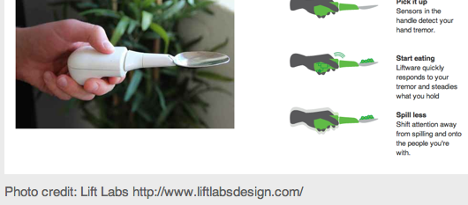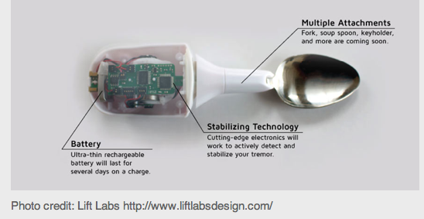
2014 Budget and what it means for people with disabilities

While the 2014 budget will lead to many changes for people with disabilities, funding for the National Disability Insurance Scheme (NDIS) is secure. Furthermore, there are currently no changes to the roll out (which is hoped to be achieved by July 2019).

However, while the commitment to the NDIS has been welcomed, the Administrative Appeals Tribunal (which is accountable for hearing legal issues associated to the NDIS) is to be merged with other tribunals. Funding toward legal aid has also been reduced.

The 2014 federal budget also proposes changes to the current social security system. These changes will impact young people in particular. Those under the age of 35 on the Disability Support Pension (who began payments between 2008-2011) will be required to have their eligibility reassessed. If found to be capable of working more than 8 hours a week, individuals will be included in a participation plan. These plans may involve Work-for-the-dole programs, and penalties will be issued to those who fail to adhere to their participation plans (the nature of such penalties is yet to be disclosed). Severely disabled individuals will be excused from this review.

Increases to pensions and allowances will no longer be calculated based on Average Male Weekly earnings, but instead will increase parallel to the Consumer Price Index. This change will also impact the Carer Payment.

The National People with Disability and Carers council has also been disbanded. It will be replaced by a newly established council, named the Disability and Carers Industry Advisory Council.

Changes to the current medicare system will also negatively effect those with disabilities. Co-payments of $7 have been introduced and will apply to general practitioner visits, pathology and many other kinds of diagnostic testing that are not undertaken in a hospital. While these co-payments apply to everyone, they only apply to the first 10 visits of each year for children and concession card holders. The price of prescriptions will increase by $5 (or 80c if you hold a concession card).
Recent research

Fruit fly research shines new light on SCA-7

Disruptive clumps of defective proteins are often attributed with impairing brain functions in patients with spinocerebellar ataxias, however a study published earlier this year in Genes and Development suggests that the mutated proteins may not necessarily need to form clumps in order to do damage.

Focusing on fruit flies, researchers at the Stowers Institute for Medical Research (led by Jerry Workman, Ph.D and Susan Abmayr, Ph.D) investigated ataxin-7, the protein that is mutated in patients with SCA-7. Their research found that fruit flies lacking the ataxin-7 gene experience a neurodegeneration in the eye and brain, similar to the effects seen in human SCA-7 patients.

Ataxin-7 protein has been known to collect in the cells of SCA-7 patients, however no current evidence exists to directly link this aggregation with the observed neurodegeneration. Consequently, these findings offer exciting new direction in identifying the cause of the SCA-7 phenotype.

Mohan, R., Dialynas, G., Weake, V., Liu, J., Martin-Brown, S., Florens, L., Washburn, M., Workman, J. and Abmayr, S. (2014). Loss of Drosophila Ataxin-7, a SAGA subunit, reduces H2B ubiquitination and leads to neural and retinal degeneration. Genes \& development, 28(3), pp.259--272.

Interferon-beta improves the physical performance of mice with SCA-7

On Monday June 10, 2013, researchers from the United States and France presented findings at the annual European Society of Human Genetics conference which suggest a new way of controlling symptoms and improving the physical condition of animal models of spinocerebellar ataxia type 7.

During the experiment mice, which were genetically modified to develop a severe type of SCA-7, were injected with mouse interferon-beta three times a week, beginning when the mice were 5 weeks of age (just before their first symptoms of SCA-7 were expected to appear). Autopsy on the brains of the mice indicated that those who received the interferon-beta injections had a reduction in mutant ataxin-7* levels.

The physical performance of mice injected with interferon-beta was found by researchers to be significantly better than the performance of the control group. Furthermore the analysis of PML nuclear bodies**, which partake in the degradation of mutant ataxin-7, indicated that mice receiving the treatment had more and considerably larger PML bodies than control mice.

One of the researchers, Dr. Annie Sittler, believes that following confirmation in another mouse model, it would be merited to test the effects of interferon-beta on humans in a clinical trial.

*The protein that is mutated in patients with SCA-7
** Structures found in the nuclear of cells. These structures are important in regulating the primary stages of cell replication and cell death.

Chort, A., Alves, S., Marinello, M., Dufresnois, B., Dornbierer, J., Tesson, C., Latouche, M., Baker, D., Barkats, M., El Hachimi, K., Ruberg, M., Janer, A., Stevanin, G., Brice, A. and Sittler, A. (2013). Interferon beta induces clearance of mutant ataxin 7 and improves locomotion in SCA7 knock-in mice. Brain, [online] 136(6), pp.1732-1745. Available at: http://dx.doi.org/10.1093/brain/awt061

